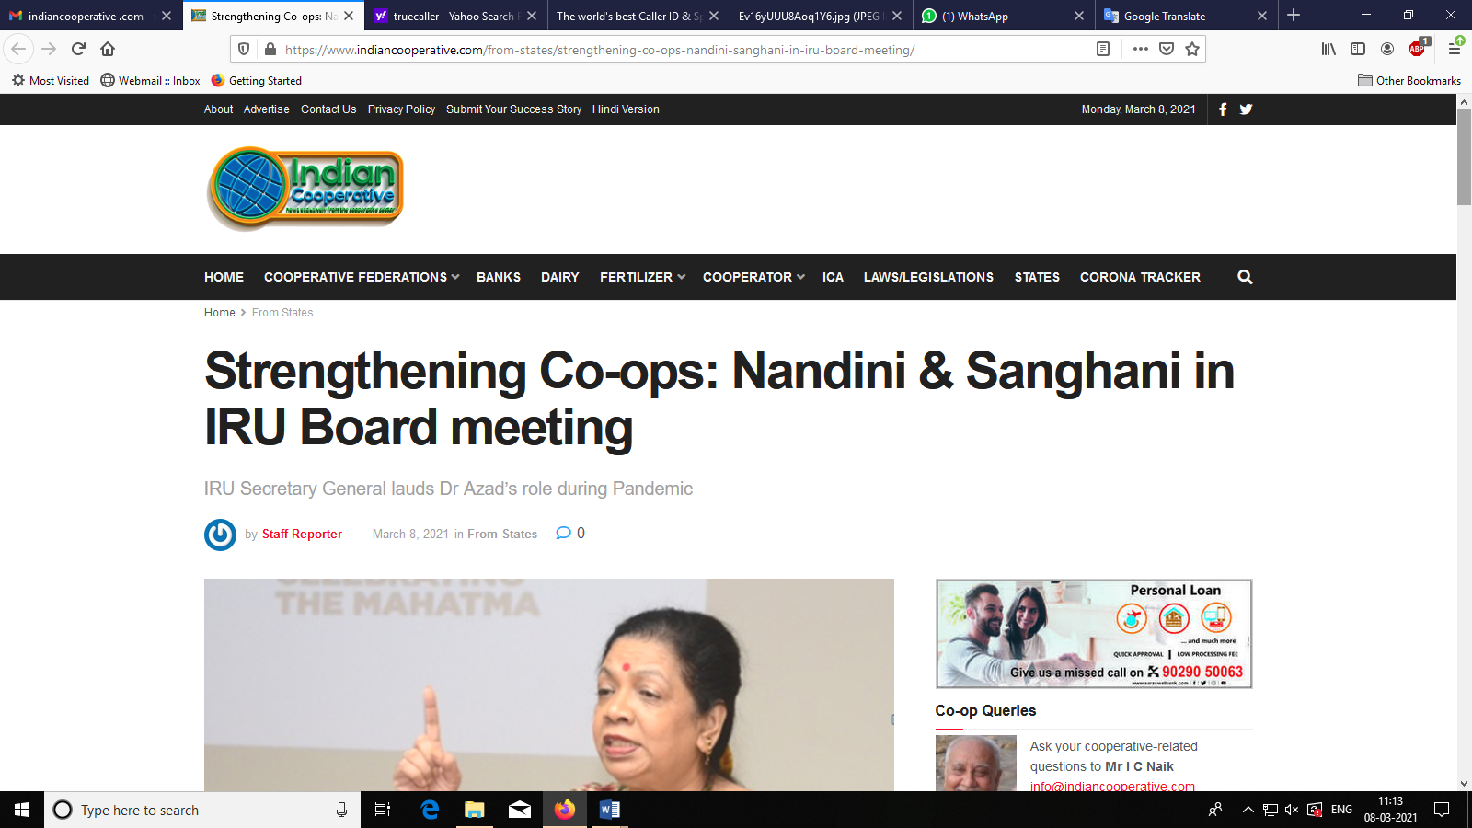

**Strengthening Co-ops: Nandini in IRU Board meeting**

**IRU Secretary General lauds Dr Azad’s role during Pandemic**

by [Staff Reporter](https://www.indiancooperative.com/author/staff-reporter/)| [March 8, 2021](https://www.indiancooperative.com/from-states/strengthening-co-ops-nandini-sanghani-in-iru-board-meeting/)in [From States](https://www.indiancooperative.com/category/from-states/)

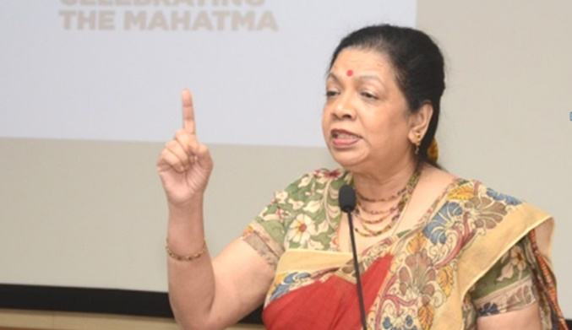The International Raiffeisen Union (IRU) held a virtual Board and Presidium meeting from Bonn, Germany on Friday, in which its only Board member from India Dr Nandini Azad was lauded for her role during the pandemic.

It bears recall that the IRU is one of the world’s oldest cooperative unions and is a worldwide voluntary association of national cooperative organisations   
having 52 members in 33 countries, including France, the Netherlands, South Africa, Austria and India.

Welcoming Dr Azad on the occasion, IRU Secretary General Andreas Kappes asked her to speak about the impact of pandemic and how co-ops battled it and emerged victorious.

Lauding IRU for being active during the pandemic with online programs keeping the oldest Union alive, Nandini narrated the tale of struggles of women co-ops especially in the southern   
states of India.

Highlighting the conditions during the lockdown, Dr Azad said for women workers there was no off take of loans in the beginning and it only started picking up by July when the lockdown was partially lifted. “The WWF-ICNW was one of the few women cooperatives to carry out a digital financial training for 65 staff members during Covid. It also motivated CEOs and interstate branches to overcome problems related to their members’ mobility”, Dr Azad underlined.

She also talked of Covid Heroines and narrated how they repaid their loans despite so much hardship. “To find out the issues of repayment the software unit took up a survey of members to be surprised that as many as 1000 members repaid loans to help their cooperative survive”, she sounded thankful.

Nandini informed the IRU Board that the late Dr. Jaya Arunachalams birth anniversary was celebrated as micro entrepreneur awards for COVID heroines.

Azad also featured in a 10-minute documentary done on her by the Lok Sabha Tv. IRU President Freddy Depickere and Secretary General Andreas Kappes wrote a mail congratulating her.

Soon after the Board meeting, President Freddy Depickere requested the IRU Secretariat to help Dr Azad contact members and others for the WWF-ICNWs panel. “The film on Dr Nandini Azad that has Raiffeisen board members in it will be IRUs offering on March 8th worldwide on social media with pride in their only woman board members achievement”, the Secretary General announced.