Nandani brings laurels to desi co-op movement
by Parasnath – 03|10|2018

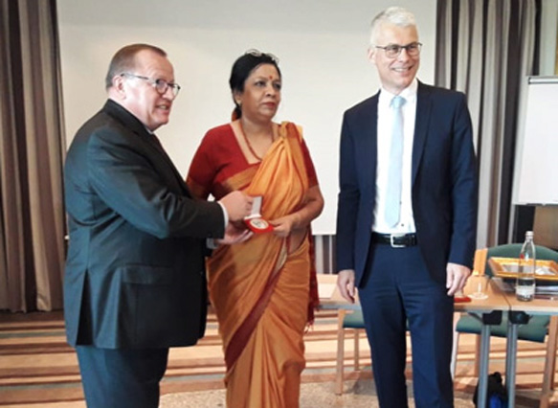
Nandani Azad, the daughter of formidable south Indian cooperator Jaya Arunachalam of WWF fame was elected to the board of the International Raiffeisen Union based in Koblenz in Germany last week.
Though, Indian cooperators might be slow in reacting to Nandani’s elevation but the Union Minister for Women and Child Development Maneka Gandhi lost no time in tweeting her victory at an international forum.
Mrs Azad is President of ICNW- a multi-State cooperative operating in Tamil Nadu, Andhra Pradesh and Karnataka. With over 6 lakh women beneficiaries involved in 276 trades in the informal sector, the ICNW promotes “new age cooperatives of grass-roots women”.
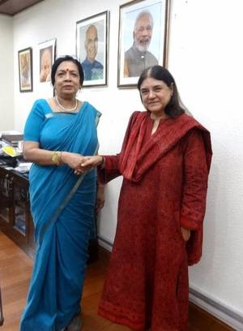
Sending a mail to Indian Cooperative Mrs Azad, who is also daughter-in-law of former Bihar Chief Minister Bhagwat Jha Azad wrote “I have great pleasure in forwarding a tweet by the Hon. Minister for Women and Child Development, Govt of India, on my election as the 1st Indian woman in 50 years to the oldest Cooperative Union in the world namely the International Raiffeisen Union in Koblenz, Germany.
The news of Nandani election has caught wide spread media attention- both local and national. Besides the dailies like The Hindu and Indian Express, several Tamil broadsheets have reported her conquest. Since 2016, Dr. Azad was a special invitee to the Raiffeisen board on gender diversity.
Mrs Azad has become the first Indian woman to be elected to the board of the International Raiffeisen Union (IRU) in Germany. The IRU is the one of the world’s oldest cooperative unions and is a worldwide voluntary association of national cooperative organisations having 52 members in 33 countries, including France, the Netherlands, South Africa, Austria and India.
Dr. Azad, who is also the chairperson of the outreach committee for the National Credit Fund for Women and E-Women’s Market Portal under the Ministry of Women and Child Development, has worked in the field of gender, cooperatives, poverty, development and financial inclusion over the last three decades.
Dr. Azad has also conducted a study spanning 18 countries on gender in cooperatives in the Asia-Pacific region. She is also the officiating chairperson of the International Cooperative Alliance – Asia Pacific Women’s Committee.

