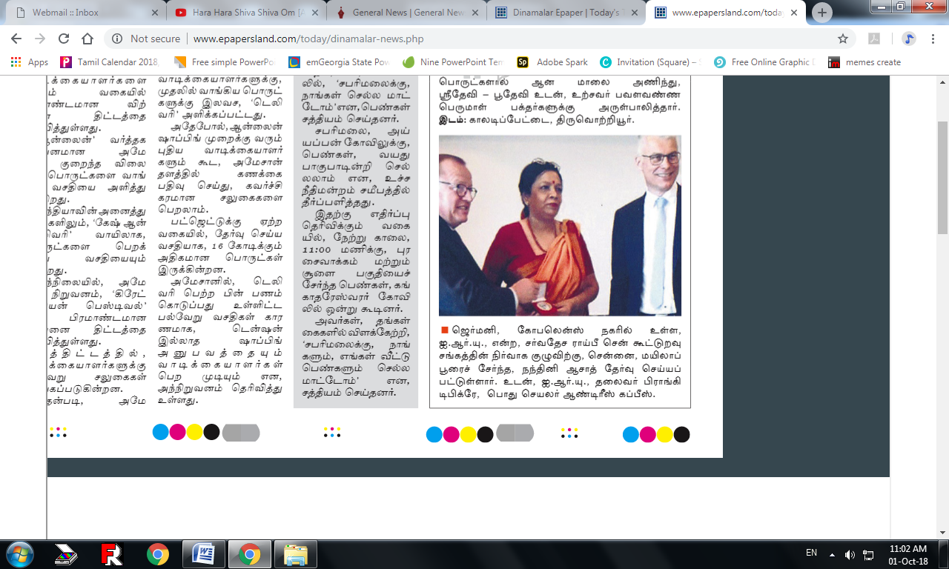Chennai, September 30th , 2018

In Germany, Dr.Nandini Azad President of the Indian Cooperative Network for Women in Chennai, India, has been elected to the Board Member of the **International Raiffeisen Union** (IRU), The oldest cooperative in the world. She is seen with the IRU President **FRANKY DEPICKERE**, General Secretary **ANDREAS KAPPES**.