**THINA THANTHI**

CHENNAI, 03-04-2018

**The 40th Anniversary of Working Women’s Forum began**

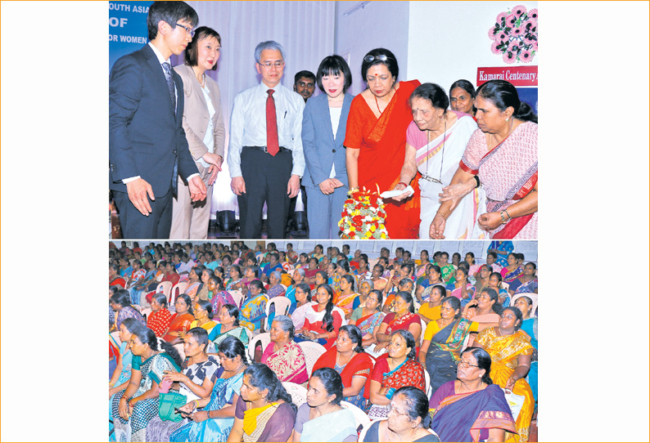

The 40th Anniversary of Working Women’s Forum (India) and the Indian Cooperative Network for Women inaugurated yesterday in Chennai.

The function of the 40th Anniversary of Working Women’s Forum (India), Mylapore and the Indian Cooperative Network for Women was held yesterday. The women cooperative members from Tamil Nadu, Andhra Pradesh and Karnataka participated in the function. The Japanese dignitaries also participated.

Jaya Arunachalam, President of Working Women’s Forum (India) and Indian Cooperative Network for Women President Nandini Azad also lighted the lamp.

Nandini Azad President of Indian Cooperative Network for Women said “The Indian Cooperative Network for Women is functioning not only in India but also in Asia towards peace, development and poverty reduction and it is impossible for women to achieve without cooperation”.

The Japan Consumer Cooperative Union’s Vice President Chitose Arai, Manager International Department Haruyoshi Amano, Senior International Officer, Kanako Miyazawa and Yoshikazu Koike participated in the event.

Many items including Sarees and earrings made by the women members were exhibited also the cultural events took place, Jaya Arunachalam President, Working Women’s Forum (India) said.

Many years ago poor women in illiterate and no one was willing to provide them credit. This was the reason to establish the Working Women’s Forum (India) in Chennai. Later it was founded in other parts of Tamil Nadu, Andhra Pradesh & Karnataka to facilitate many women to do business with the facilitation of credit. So far over 20 lakh people have been provided credit.

Now women are in good position the 40th anniversary of Working Women’s Forum (India) and Indian Cooperative Network for Women have brought in the prominent people from the Japan Consumer Cooperative Union to witness the women’s work and also to learn and share the cooperatives ideas and towards cultural exchange. The ceremony took place in Chennai today (Wednesday) and tomorrow in Kancheepuram Jaya Arunachalam said.

**DINAMALAR**

Chennai, 03-04-2018

**For the 40th Anniversary women of Working Women’s Forum Assembles in Chennai today and Tomorrow.**

The Indian Cooperative Network for Women and the Working Women’s Forum (India) celebrate the 40th Anniversary to day in Chennai from (1.30 p.m. to 4.30 p.m.) This event is a joint collaboration of cooperatives towards peace, development and poverty reduction in South Asia.

These two organizations are the symbol for the progress of mass movement of 14 lakh poor women workers in 14 cooperatives in Tamil Nadu, Andhra Pradesh and Karnataka. These organizations were set up in Chennai in 1980 with 800 women. It is now one of the modern social and economic cooperatives for women's power in the Asian region. These institution facilitated 6 lakh women not only towards income generation, savings, business improvement but also facilitated health care, insurance and voiced their grievances and are a hope to voice for better society. At this event, weavers, lace weavers, fisher women, vegetable sellers and other small entrepreneurs of the cooperative will participate.

This is the first campaign at Asia level to focus on the poor women's co-operation in the International Peace relation in relation to the United Nation sustainable development goals. The dignitaries from the Japan Consumer Cooperative Society has come here in India to promote awareness about the need for peace for sustainable development.

The Japanese Consumer Cooperative Union has 37.9% of consumer activities in Japan – the leading consumer cooperative of Japan. Chitose Arai, Vice President of Japanese Consumer Cooperative Union & the International Cooperative Alliance Vice President, along with Haruyoshi Amano, Kanako Miyazawa, and Yoshikazu Koike will participate.

Nandini Azad will read the inaugural address of Daniela Bas, Director, Division for Social Policy and Development, Department of Economic and Social Affairs. Nandini Azad will give the inaugural address at this even who is currently the Vice Chairperson of International Cooperative Alliance for Asia and Pacific region. Jaya Arunachalam the founder President of the Working Women’s Forum (India) will share her experiences.

The nuclear destruction that took place in Japan and its photographs will be exhibited and forms the highlight of this function.